When I tried to get this play-by-play data to load last year, I got stuck with an error that R couldn’t access or find the information at the Github site where this data lives. The same thing happened when I attempted to get the data for this assignment, but I eventually figured out that changing the end of the address to “csv” would allow me to instead import it through the read_csv function and voila, workable data!
The first step after using the head function to confirm I had legible data was figuring out the poswins column which indicates whether the team in possession of the ball would eventually win the game. I looked through the various columns offered and couldn’t find anything about the final score, just the score at the time of the play. I realized at this point that a lot of the work I’ve done in R has been running stats calculations but not manipulating dataframes with joins and combining them as I do in SQL for my job on a daily basis. After a quick Google I found a wonderful Powerpoint deck that explained the different functions like filter, select, mutate, etc. very well and off I went. First was selecting the final score for the home and away teams as the max of their score for that game. After comparing the two teams’ max scores to determine the winner, I joined back to the data table (the original from the csv) to create a new pos_winner table, with the new poswins column, first hurdle conquered.
From there I decided to do a bit of cleanup to deal with some odd results coming through. I remembered that some rows included game start, end, timeouts, etc. Some of the results coming through were duplicated as the posteam column was not always filled, but I couldn’t get R to recognize when a column was blank (but not NA) and remove it. My next idea was to find a way to ensure a play was run, and the first column to stand out was play_type. With only 10 distinct values, I could take out the blank entry, and no_play, leaving “good” values like pass, punt, extra_point, but I also decided to leave kickoff and QB_kneel. With that small table as an option for filtering the data table, I joined it to the pos_winner table on game_id and drive, as each drive would be a different possession. After grabbing the relevant details to be used in the regression down the line (down, qtr, game_seconds_remaining, etc.) the next step was getting to the regression itself.
First off a train/test split was used to grab a random 80% of the data using the standard 123 seed. Next the glm function was used for the regression, predicting poswins based on the other details in the training set. According to the summary function’s output, every detail was significant, but as we’ll see soon in a confusion matrix that may have been overstated.
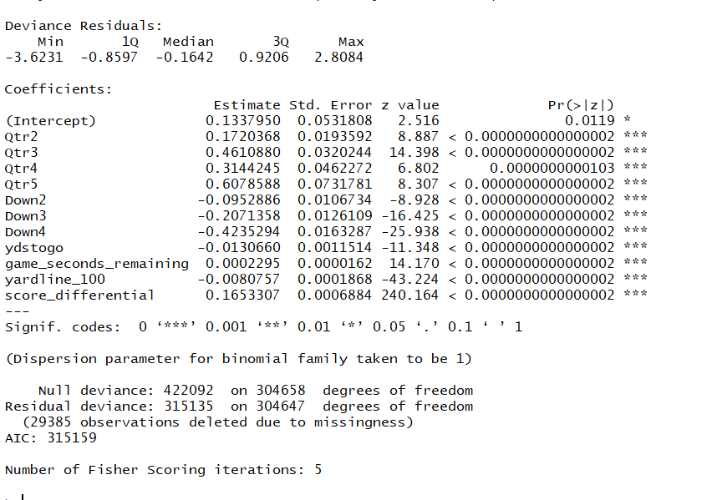
Figure 1. Summary output of linear model
Next up was creating a confusion matrix as a quick check for the accuracy of our poswins versus home_wp (home win potential). For this the function ordered was used to prep the Yes/No entries for the table function, giving us the following:
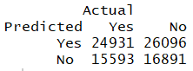
Figure 2. Confusion matrix of Predicted poswins versus Actual win
It can be seen that the results are not optimal. While there are many factors that could contribute to these mixed result, first and foremost is that the “official” win probabilities like those mentioned in the StatsbyLopez article¹ could be similarly messy, and as he says “essentially they’re all wrong”. Additionally there is a chance it was done incorrectly which would be fixed in the code. One would imagine it may be the former option as the home_wp and pred1h (the modeled percentage from this study) are generally quite close. Lastly, it would track that not every win percentage is going to be correct. It would be interesting to expand this to see which games had only one side winning the entire time, with the home_wp above or below 0.5 the entire time. Unless that’s the case, some of the win% would be wrong as it would not predict the outcome correctly. Especially with a late comeback or even game where the win% crosses 0.5 often, there will be many plays that have the incorrect choice.
Speaking of that home_wp and pred1h comparison, next up in the R code is a couple ggplots showing the game to be discussed further, the week 15 matchup between the Seahawks and Eagles. First the prediction was altered so it reflected the home team specifically, rather than the win percentage flipping across the 0.5 line every time the ball changed over. This way there would not be essentially a step function breakup in the line frequently throughout the graph. The aesthetics and legend in R are still a work in progress for this researcher who could not figure it out.
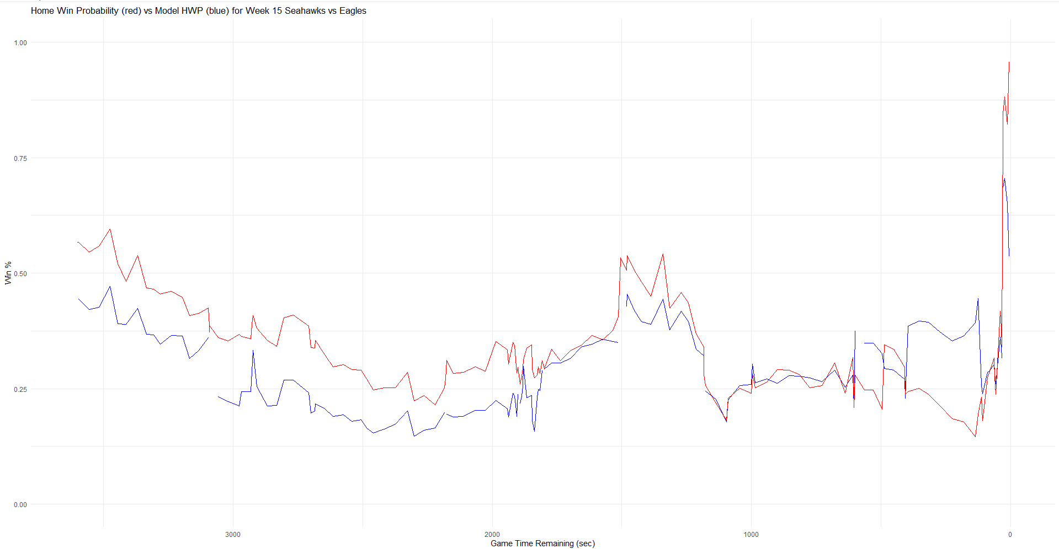
Figure 3. Home win probability from nflfastr versus the model’s values.
A couple initial notes on this comparison: there is a win percentage for every play listed with the nflfastr version, so improvements could be made to the modeled percentage, either connecting the line points or improving the functionality to run on those plays as well. This may simply require a join from the predictions back to the original dataset. Also, the modeled percentage seemed to be a bit more pessimistic in terms of the home team’s (Seahawks) chances to win. The largest difference seems to be in the last quarter, where the modeled percentage estimates a higher chance for Seattle but ends lower than the nflfastr version. The overall downward trend in the first half shows the Eagles holding a steady 7 or 10 point leading into the half, with a slight upward trend into the half as the Seahawks kicked a Field Goal to bring it to a one-score game. The second half was a bit more exciting as seen by the more “active” line. For example, there is a jump from 0.40 to 0.53 after a 23yd touchdown by Kenneth Walker III that brought the score from 3-10 to 10-10, indicating that Seattle was a bit more likely to win even though they were tied and about to hand the ball over to the Eagles. This tracks with the game’s initial value indicating Seattle was the stronger team, having about a 60% chance to win from the outset (It was at this point the researcher discovered there is a final score column, and many more that the researcher did not previously know about with R truncating the View output…) Later on there is a spike from 0.21 to 0.34 when Jalen Hurts throws an interception when only leading by 4 points. The Seahawks don’t end up doing much in that possession, running for a handful of yards and an incomplete pass, and after punting it back the win% returns to a similar value (0.24) with the Eagles having essentially moved back and with a bit less time on the clock but still leading.
The biggest spikes are seen at the end of the game, with a 14% chance for the Seahawks while still trailing by 4 points with 2:15 remaining in the game. After this, the Seahawks get the ball back off of an Eagles punt and drive down the field to score a 29yd touchdown thrown by Drew Lock to Jaxon Smith-Njigba with 33 seconds left on the clock. That play brought the win% from 34% to 84%, and it stayed close to that for the rest of the game. On the Eagle’s next possession Hurts throws another interception, and Drew Lock seals it with a QB kneel.
While the model created in this study did a good job following the action similar to nflfastr’s, it would be interesting to see why the difference was as stark towards the end, why it is generally more pessimistic for the home team than nflfastr’s, and to train it further to recognize the game coming to a close, ending with a 100% or 0% for each game. The model could always use more data to feed in, further training, and potentially adapting with other methods not just linear regression. It can still be useful, however, as one could “plug in” a situation and see the win% predicted, judging whether punting it or going for it on the 4th down would be a better situation for the team. For example in recent years teams have realized they should elect to not score a touchdown when tied towards the end of the game and it could instead be kneeled and kicked to win. If they score, the other team gets the ball back and could go for 2 instead and win instead, or tie and go to overtime. As long as there is a second left on the clock, the team could score and win.
In regards to utilizing this model, one could plug in the current state (4th and 1 at midfield with 50sec left, etc.) to check the win%, check what an average punt would end up creating for a state (opponent’s ball at their 10, 1st and 10, etc.) versus going for it and making / missing it, and make an appropriate decision based on the differences. Nowadays national game broadcasts are able to include these “Analytics” calls and compare the decisions, noting when coaches are more likely to go for it anyway or are conservative and would rather play it safe. One example is Dan Campbell for the Lions, where he goes for it on 4th down more than the rest of the NFL where they would just punt the ball away. On its face value, this makes sense as the team is attempting to separate the opponent from the endzone, and when close enough to the opponent’s endzone there is a chance of kicking into a touchback rather than being able to “cut loose” like a punter can when closer to their own endzone.
Finally looking at a chapter from Mathletics, it seems like Ch. 22 hits at a classic question in sports: why not pass every play? It’s assumed the pass play should end up getting more yards, so why would a team want to run it other than to add some unpredictability to the defensive decision making. From an analytics point of view, it would be incredible to just plug in the current situation and have an algorithm spit out the “correct” or at least best answer for a play to call, either that pass or run option. The chapter clearly lays out why being able to call an optimal play that maximizes potential outcome regardless of the defense’s decision would be incredibly useful. This and chapter 20 go hand-in-hand, where this pretend algorithm would take all of this game theory and states information to give the best few calls. This is comparable to Madden’s games suggesting a few plays to run, and it would be interesting to see how the game logic comes up with those. It can be assumed that Madden also uses a bit of a state system along with the playbook from the team you select (west coast offense, heavy on slants, etc.). This obviously ties back into Ch. 21 as well which ties the ideas together, determining whether to punt, accept a penalty, etc.
I’ve recently considered conducting similar research for rugby, determining the effectiveness of running close, medium, or far from the ruck, determining which teams are most effective and how to replicate their success. Similar analysis could be completed by looking at teams that go out on the edges, or kicking back / returning a ball kicked to the backline. This also aligns with the run/pass option for defenses in football where in rugby the choice is basically blitz or drift. Lastly, looking at 50/22 conversion rate as it relates to territory and points per game would be a worthwhile analysis.
More specifically for Ch. 22, it’s interesting to try and determine how to maximize a minimum function, knowing that the defense will always look to match the run/pass selection and often succeed in limiting yard when doing so. Cutting the issue down to a simplistic 4-value matrix makes the calculations easier, and while it would be great to include every formation, choice of who to pass to, etc. that is probably not realistic at the moment. Finding a percentage of each choice through the Nash equilibrium between the offense and defense would be very helpful to a team, where they could aim to hit that balance throughout the game. Ideally it would be possible to find all these matrix values, run the equations, and look to hit that balance, but also that situational calls could make the numbers not useful anyway. If a team has 70yds to go to score the go-ahead touchdown with time running out, but you haven’t hit the “quota” for the running plays to hit that optimal balance, it’s unlikely that a run play would still save the game for you. Essentially, this mentality shouldn’t be used as a silver bullet, but instead to inform what sort of balance will be useful, and potentially lead to more analysis on why certain plays/balances work well together. Similar to the Chris Paul example from the Severini³ reading in Ch. 5, it would be interesting to see an autocorrelation between run and pass plays, and that while constantly switching between the two is probably not optimal, neither would running a ton of passes or rushes in a row.
In using this Mathletics reading for a given team, it would be suggested that a team could work with the given states so far in the season, and attempt to find the current values for the variables in the payoff matrix given in Table 22.2. As those are created throughout a season, especially with specific formations considered, a team can have a better idea of their effectiveness in choosing runs and passes, and along with a bit of human intuition, pick the best next play to run in pursuit of a win.

References:
¹ statsbylopez. 2017. “All Win Probability Models Are Wrong — Some Are Useful.” StatsbyLopez. March 8, 2017. https://statsbylopez.com/2017/03/08/all-win-probability-models-are-wrong-some-are-useful/.
²Winston, Wayne L. 2012. Mathletics : How Gamblers, Managers, and Sports Enthusiasts Use Mathematics in Baseball, Basketball, and Football : With a New Epilogue by the Author. Princeton: Princeton University Press.
³Severini, Thomas A. 2020. Analytic Methods in Sports. CRC Press.

